**Assignment 02**

Explaining the working of the assignment:  
Action 1 Load and Login.

1. This ensures that the action is **only executed once**
2. DataTable.GetCurrentRow checks the **current row index** of the global data table
3. A close-up of words

   AI-generated content may be incorrect.If the script is already executing past the **first row**, it calls ExitAction to **stop execution**

This checks if the global table already exists or not and then if not exists it creates one, we have also defined a const variable excelPath which has the file path to the excel file from which the data is being read and written to the global table.  
  
This in itself is self-explanatory, basically adding necessary columns for data from the excel file to be written.  
  
For reading the excel file we need to first create and object or a dim in vbscript   
you can see as it is shown   
  
the above script helps populating the global table with the data from the excel file  
after writing the data into the global table we close the excel file without saving   
and clear the memory   
  
Firstly it logs the pass event in the UFT to confirm the data import was successful

Then it checks if the application is already open or not, if it is not then it opens the application

Then it goes to the first row and takes the username as AgentName and password and logins in the application.  
here it checks If the login is successful then   
after that the Action is stopped and it moves to the next action  
  
Action 2 Book and close

In the above code we have defined a path to the screenshot folder   
Then initialized a flag which checks if the application has is launched or not   
Also the function makes sure to check if the application has been launched before running the script or not   
  
  
  
If the app is not launched, it launches the app and logins in the first customer

Loops through the global data table dynamically and extract details from the table

  
this is for the fail checkpoint, where the passenger is 0 then the script logs a failure event

after the failure checkpoint, it closes the app waits for 2 seconds

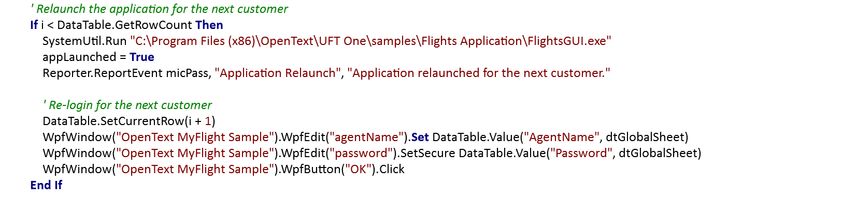  
  
After waiting for 2 seconds, it launches the application back.

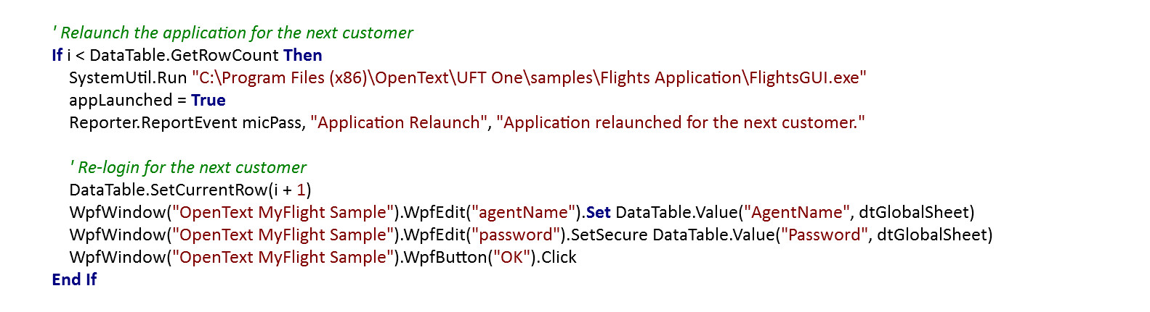  
it checks if there are still more customers left then it re logs back in for the new customer.

now if there is no failure case then it takes a screenshot before and after filling the form  
  
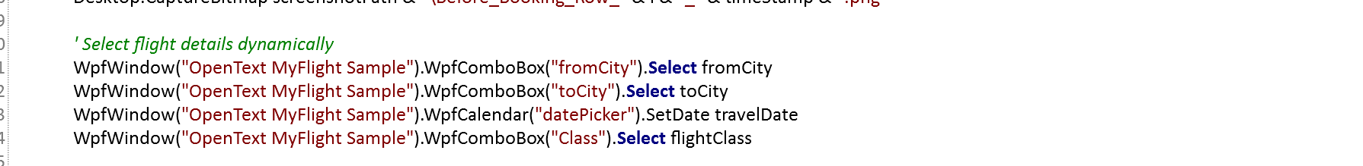  
it dynamically fills in the details for the flight



There are two bitmap checkpoints namely “Find flight” button and “Seattle to San Francisco”.  
And one text checkpoint to check “John Smith”

checks if there is a dropdown option waits for 2 seconds then enters the then case  
here it checks the number of tickets to be selected through the global table and then logs a pass event that tickets successfully selected  
If not then it logs a fail event  
  
it then clicks on the find flights button, selects a flight details from the row 2 and column 3 and then click on the select flight button

You also validate if the name of the passenger is entered correctly or not.